**Six Ways to Rank Professional Quarterbacks**

**followed by a head-to-head of the Top Two: Graham and Brady  
(for details, see http://yeinfo.com/qb)**

|  |
| --- |
| **#1 based on Stats and Weighted Values** (NOTE: more # of seasons helps here)**:** |
| = #ChampionshipsTimesFour |
| + CountOfFiveStrengthIndicators(StrongArm,Mobile,Leadership,Clutch,Smart) |
| + WinningSeasonsStarter |
| + #OfUndefeatedRegSeason |
| + #TeamWinDiv |
| + #TeamWinConf |
| + #PlayoffWinsAsStarter |
| - #PlayoffLossesAsStarter |
| + PlayoffWinPct |
| + Playoffs4QComeback |
| + PlayoffsGameWinningDrive |
| + #ProBowls |
| + #ProBowlStarter |
| + #SeasonsMVP |
| + #SeasonsAPAllPro |
| + #HallOfFame |
| + #Championships |
| + #ChampionMVP |
| - #PlayoffLosses |
| + QBRatingValue[100+=3,90-99=2,80-89=1] |
| + 4QComebackValue[40+=3,25-39=2,15-24=1] |
| + WinningDriveValue[40+=3,25-39=2,15-24=1] |
| + WinLossRatioValue[90+=4,80-89=3,70-79=2,60-69=1] |
| + FumFumLostRatioValue[0-29=3,30-39=2,40+ =1] |
| + WinningSeasonsValue[100%=4,90-99=3,80-89=2,70-79=1] |
| + YdsPerAttValue[8.75+=3,8.25-8.74=2,7.75-8.24=1] |
| + TDGameRatioValue[2+=3,1.5-1.9=2,1-1.4=1] |
| + GamesPlayVsMissValue[100%=4,90-99=3,80-89=2,else=1] |
| + DecadeValue(forChangsesInGameOverTime)[1970-1989=3,1950-1969=6,before1950=9] |

**TOP TEN**: Graham(255), Brady(235), Montana(175), P.Manning(157), Unitas(156), Starr(155) Mahomes(152), Elway(146), Luckman(144), Bradshaw(143),

**Rest of Top 25**: Roethlisherger, Favre, Staubach, Layne, Rodgers, Aikman, Lamonica, Brees, E.Manning, Morrall, Warner, Baugh, Young, Wilson, Waterfield

|  |
| --- |
| **#2 based on weighted Championships Won** (NOTE: more # of seasons helps here)**:** |
| = #ChampionshipsTimesFour |
| - #PlayoffLosses |
| + CountOfFiveStrengthIndicators(StrongArm,Mobile,Leadership,Clutch,Smart) |
| + WinningSeasonsStarter |
| + #OfUndefeatedRegSeason |
| + #TeamWinDiv |
| + #TeamWinConf |
| + #PlayoffWinsAsStarter |
| - #PlayoffLoseAsStarter |
| + PlayoffWinPct |
| + Playoffs4QComeback |
| + PlayoffsGameWinningDrive |
| + #ProBowls |
| + #ProBowlStarter |
| + #SeasonsMVP |
| + #SeasonsAPAllPro |
| + #HallOfFame |
| + #Championships |
| + #ChamptionMVP |
| + QBRatingValue[100+=3,90-99=2,80-89=1] |
| + 4QComebackValue[40+=3,25-39=2,15-24=1] |
| + WinningDriveValue[40+=3,25-39=2,15-24=1] |
| + WinLossRatioValue[90+=4,80-89=3,70-79=2,60-69=1] |
| + FumFumLostRatioValue[0-29=3,30-39=2,40+=1] |
| + WinningSeasonsValue[100%=4,90-99=3,80-89=2,70-79=1] |
| + YdsPerAttValue[8.75+=3,8.25-8.74=2,7.75-8.24=1] |
| + TDGameRatioValue[2+=3,1.5-1.9=2,1-1.4=1] |
| + GamesPlayVsMissValue[100%=4,90-99=3,80-89=2,else=1] |
| + DecadeValue(forChangsesInGameOverTime)[1970-1989=3,1950-1969=6,before1950=9] |
| + Points:WinsPerGamesPlayed% (90+=10,80-89=8,75-79=6,70-74=4,65-73=2) |
| + Points:WinningSeasonsToSeasonsPlayed% (100=10,90-99=8,80-89=6,70-79=4,65-69=2) |
| + Points:TDsIntsRatio% (2.8+=10,2.6-2.7=8,2.1-2.5=6,1.8-2.0=4,1.3-1.7=2) |
| + Points:FumLostFumRatio% (0-1.2=10,1.3=1.45=8,1.46-1.47=6,1.48-1.59=4,1.60-1.99=2) |
| + Points:#Sacked (0=10,1.1-1.3=8,1.4-1.5=6,1.6-1.7=4,1.8-1.9=2) |
| + Points:IntsPerAtt% (0-0.4=10,0.5-0.9=8,1.0-1.3=6,1.4-1.6=4,1.7-1.9=2) |
| + Points:IntsPerAtt (0-1.9=10,2.0-2.4=9,2.5-2.9=8,3.0-3.4=6,3.5-4.4=5,4.5-4.9=3) |
| + Points:YdsPerAtt (8.6+=1-.8.5-8.7=8,7.6-8.4=6,7.1-7.5=4,6.6-7.4=2) |
| + Points:YdsPerComp (17+=10,16.x=8,15.x=6,14.x=4,13.x=3,12.x=2) |
| + Points:YdsPerGame (271+=10,251-270=8,226-250=6,201-225=4,181-200=2) |
| + Points:TDPerAtt (7.1+=10,6.x=8,5.6-5.9=6,5.1-2.5=4,4.6-5.0=2) |
| + Points:TDPerGame (2.1+=10,1.7-2.0=8,1.4-1.7=6,1.2-1.3=4,1.1=2) |
| + Points:IntPerGame (0-0.5=10,0.6-0.71=8,0.72-0.79=6,0.80-0.85=4,0.86-0.99=2) |
| + Points:#GamesPlayedVs.Possible (1+=10,0.95-0.99=8,0.898-0.949=6,0.848-0.897=4,0.8-0.847=2) |
| + Points:4QWinPerGame (18+=10,15.1-18=8,12.1-14.9=6,10.1-12=4,8.1-10=2) |
| + Points:WinningDrivePerGame (20+=10,17.1-20=8,15.1-17=6,12.1-15=4.10.1-12=2) |

**TOP TEN**: Brady(360) ,Graham(286) , Mahomes(267), P.Manning(263), Montana(262), Unitas(236), Starr(222), Luckman(219), Roethlisherger(215), Wilson(209)

**Rest of Top 25**: Brees, Elway, Bradshaw, Rodgers, Staubach, Marino, Favre, Layne, Young, Lamonica, Aikman, Morrall, E.Manning, Van Brocklin, Waterfield

|  |
| --- |
| **#3 based on Weighted Pointed for Winning:** |
| = #ChampionshipsTimes12 |
| + #ChampionshipsTimes11 |
| + (#WinDiv/#YrsPlayed)Times10 |
| + (#WinConf/#YrsPlayed)Times10 |
| + previousTwoValuesTimes10 |
| + #WinningSeasonsTimes9 |
| + TDGameRatioValue[2+=3,1.5-1.9=2,1-1.4=1]Times8 |
| + (4QComebackValue[40+=3,25-39=2,15-24=1] |
| + WinningDriveValue[40+=3,25-39=2,15-24=1] |
| + WinLossRatioValue[90+=4,80-89=3,70-79=2,60-69=1])Times7 |
| + QBRatingValue[100+=3,90-99=2,80-89=1]Times6 |
| + FumFumLostRatioValue[0-29=3,30-39=2,40+=1]Times5 |
| + #MVPofYearTimes3 |
| + #ProBowlStarterTimes2 |
| + GamesPlayVsMissValue[100%=4,90-99=3,80-89=2,else=1] |
| + #SeasonsAPAllPro |

**TOP TEN**: Graham(493), Brady(471) , Mahomes(321), P.Manning(316), Montana(303), Luckman(266), Starr(261), Bradshaw(251), Staubach(239), Unitas(231)

**Rest of Top 25**: Roethlisherger, Waterfield, Elway, Rodgers, Favre, Aikman, Brees, Van Brocklin, Layne, Baugh, Conerly, Griese, Wilson, Kelly, Isbell

|  |
| --- |
| **#4 based ONLY on Averages and Percentages:** |
| = QB Rating (((PassComp%+PassInt%+TDAtt%+YdsAtt/6)*100) |
| + AvgYdsPerComp |
| + 100-AvgFumGame |
| + 100-FumToFumLost% |
| + YdsPerRush |
| + TDPerRush |
| + TDRushGame |
| + GamesStart% |
| + GamesStartWin% |
| + WinningSeason% |
| + SeasonsMVP% |
| + SeasonsWinDiv% |
| + SeasonsWinConf% |
| + PlayoffWins% |
| + SeasonsProBowl% |
| + SeasonsProBowlStart% |
| + SeasonsAPAllPro% |
| + 20MinusSeason#AsChamp (i.e. how many seasons did it take QB to win first championship) |
| + SeasonsChamp% |
| + SeasonsChampMVP% |

**TOP TEN**: Mahomes(1645), Graham(1503), Staubach(1414), Young(1383), Starr(1381) , Bradshaw(1333), Jackson(1329), Rodgers(1323), Wilson(1318), Montana(1300)

**Rest of Top 25**: McNabb, Allen, Unitas, Tarkenton, Vick, Cunningham, Elway, Newton, Luck, Jones, Warner, Isbell, Anderson, Theismann, Lamonica

**Missing here are: Brady(#26), P.Manning(#33), Roethlisherger(#42), Luckman(#68)**

|  |  |
| --- | --- |
| **#5 Points per Stats Ranking:** | |
| Rating | |
| #Attempt | |
| #Comp | |
| #Yards | |
| Comp% | |
| #TD |  |
| TD/Int |  |
| TD/Att | |
| TD/Game | |
| #Fumbles | |
| #FumbLost | |
| FumLost% | |
| Fum/Game% | |
| #Sack |  |
| Sack/Game | |
| Int/Att |  |
| Yd/Att |  |
| Yd/Comp | |
| Yd/Game | |
| Int/Game | |
| AvgRushYards/Game | |
| AvgRushTD | |
| AvgRushTD/Game | |
| #GamesPlayed | |
| #Games/Played | |
| #SeasonsPlayed | |
| #Games/Started | |
| #PROBowl | |
| #PROBowlStart | |
| #MVP |  |
| #APPro1stTeam | |
| #4QComebackWins | |
| #WinningDrives | |
| #4QWin/Game | |
| #WinDrives/Game | |
| #Wins | |
| Win%Games | |
| #WinSeasonsStarter | |
| WinSeasons% | |
| #UndefeatedSeason | |
| #WinDivision | |
| #WinConf | |
| #PlayoffGames | |
| #PlayoffWins | |
| #PlayoffWin% | |
| #Playoff4QWin | |
| #PlayoffWinDrive | |
| 1stSeason#InSBowl | |
| #SB/Champ-Wins | |
| #SB/Champ-MVP | |

**TOP TEN**: Brady(118), Graham(65), P.Manning (64), Brees(47), Montana(34), tied for #6 are Favre(32) and Luckman(32), Blanda(31), Starr(29), tied for #10 are Mahomes(26) and Isbell(26)

**Rest of Top 25**: Waterfield, Unitas, Morrall, tied for #15 are Baugh and Roethlisherger, Rodgers, tied for #18 are Williams and Elway, Wilson, tied for #21 are Namath and Ryan, Layne, Bradshaw, three-way tie for #25 are Hostetler, Warner, Luck

**Combination of all above Rankings**

(16 Quarterbacks Listed)

|  |  |  |
| --- | --- | --- |
| **Combining the Ranks with the five Top Ten Rankings with a Point assigned per Rank value where 1 is 10pts, 2 is 9pts, 3 is 8pts and so on where 10 is 1pt and zero is zero points**  **(*Names in Red played before 1960*)** | | |
| **QB and his five Rankings** | **# of times Ranked** | **Points for Combined Rankings** |
| Graham:1,2,1,2,2 | **5** | 47 |
| Brady:2,1,2,0,1 | 4 | 40 |
| Mahomes:7,3,3,1,10 * | **5** | 31 |
| P.Manning:4,4,4,0,3 | 4 | 29 |
| Montana:3,5,5,10,5 | 4 | 27 |
| Starr:6,7,7,5,9 | **5** | 21 |
| Luckman:9,8,6,0,6 | 4 | 15 |
| Unitas:5,6,10,0,0 | 3 | 12 |
| Staubach:0,0,9,3,0 | 2 | 10 |
| Brees:0,0,0,0,4 | 1 | 7 |
| Young:0,0,0,4,0 | 1 | 7 |
| Bradshaw:10,0,8,10,0 | 3 | 5 |
| Favre:0,0,0,0,6 | 1 | 5 |
| Blanda:0,0,0,0,8 | 1 | 3 |
| Elway:8,0,0,0,0 | 1 | 3 |
| Wilson:0,10,0,9,0 * | 2 | 3 |

* QB’s active in the 2023 season

**Head-to-Head: Graham and Brady**

**Since Brady played 13 more seasons than Graham, numbers (i.e. # TDs, # Yards, etc.) are not an apples-to-apples comparison. Thus, given their respective statistics, calculate some percentages and averages (which “levels the playing field”) for Otto Graham and Tom Brady to show what is most likely to happen per play they execute.**

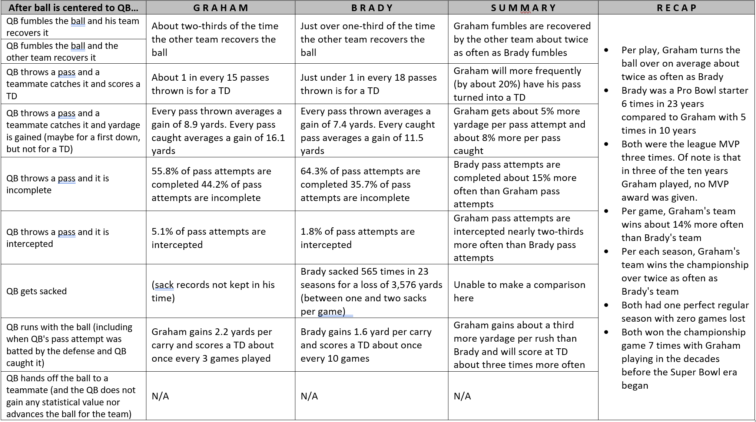

In short, Graham and Brady are equals with total number of championships played and won, number of times as the league MVP, and, their one perfect season each. On the negative side, on average, Graham will turn the ball over (fumbles and interceptions) more often than Brady will. On the positive side, on average, Graham’s passes and runs gain more yards and more TDs than Brady’s. And, on average, Graham’s team wins more often than Brady’s team.

Graham (played 1945-1955): #1 for average yards per pass, #1 for win-loss percentage of games he started, #1 for winning seasons percentage, #2 for average yards per completion, #3 for TDs per pass, and, in his career, he started 100% of all his team games.

Brady (played 2000-2022): #3 for win-loss percentage of games he started, #1 for # TDs vs. # Ints, #1 for fewest Ints per Pass, #1 for smallest fumbles percentage per play, #3 for percentage for # of games started to # games his team played.

In the year 2090, how many quarterback records of Brady’s will still stand? And, will Graham’s amazing numbers also have been surpassed? Time will tell!

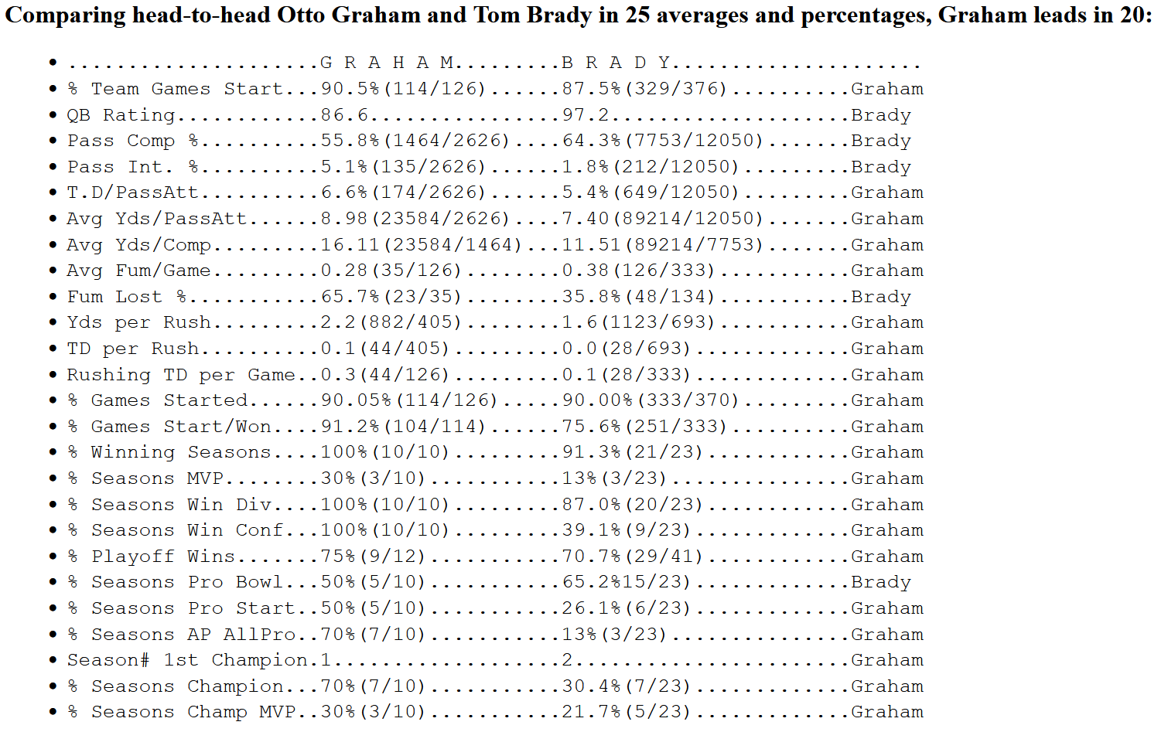

**Bottom Line -- Brady leads Graham in these ways:** 1. Completes a higher percentage of passes  
 2. Loses the ball less with fumbles  
 3. Total QB Rating  
 4. Selections to the Pro Bowl (*playing over twice the number of seasons of Graham helps with this one*)  
 5. More seasons played

Graham either leads or is equal to Brady in every other way that a quarterback can be measured!!!

**For more details, see**

[**http://yeinfo.com/qb**](http://yeinfo.com/qb)

**Without specifying HOW they rated and ranked for the Greatest Quarterback,   
anyone who claims that Tom Brady is “The G.O.A.T.”)   
just might be guilty of at least one of these three definitions**

